I wrote a simple application with Microsoft visual studio C# with one form.

I like to make a trial use of this software and use an activation key to activate it when a user is running it, as I describe next.

You have to write and an other application to generate the activation key from the ID of the user’s computer.

The final visual studio project it should return to me at the same format because my code is still under development and I want to add more.

Description:

When running for first time, the application will open and we see the following window. The program has to generate a unique number from the computer’s windows key or Bios and this is the ID on the registration dialog window. Then the user is sending manual the ID to programmer’s email to generate the serial number.

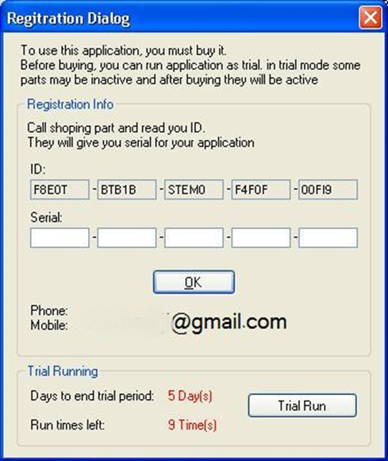

When the programmer generates the serial number with an other application he send it to the user. The user input the serial number and the application is starting if this is the correct one. There is one pop up window that activation is completed.

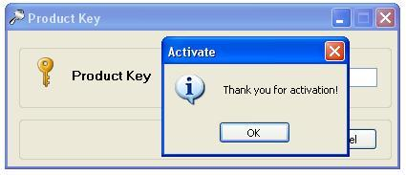

If the serial number is wrong then there is an other pop up window that says that activation key is not valid.

If the user likes to run the trial then it starting the main application according the days left. When trial finish the main application does not run any more, only the registration dialog.

When we uninstall the trial software from the computer and install it again it should keep somewhere the remaining days of the trial so the user cannot run it again after trial is expired.

It should keep the same activation key if the user uninstall the software form the computer and install it again at the same computer.